**RSV Roving Vaccination Van**

Tuesday 17th September 2024

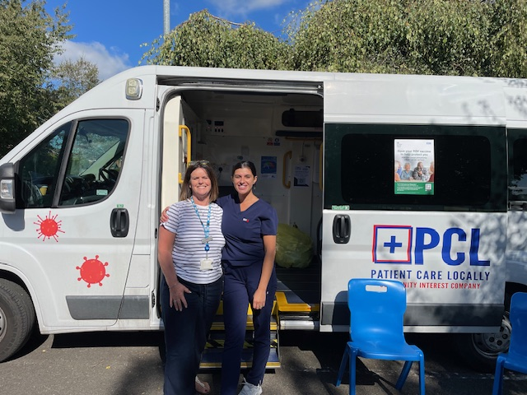

NHS England released a campaign at the beginning of September for GP practices to vaccinate as many of our 75 – 79 years old patients with the new Respiratory Syncytial Virus (RSV), before the roll out of Covid and Flu in October.

We borrowed the PCL van and held a drop-in session on the 17th September 10am – 4pm at the Markfield Community Centre car park.

We sent out 400 SMS text invites.

We vaccinated 96 patients on that day and another 61 within clinics.

We will continue to offer RSV clinics in November once the majority of Flu and Covid have been given.