HEALTH EDUCATION EVENT 12th September 2024

Eleni Robinson from the NHS Diabetes Prevention Programme LLR attended.

Eleni spoke to patients about the pre-diabetes education programme and signed up 4 patients to the programme.

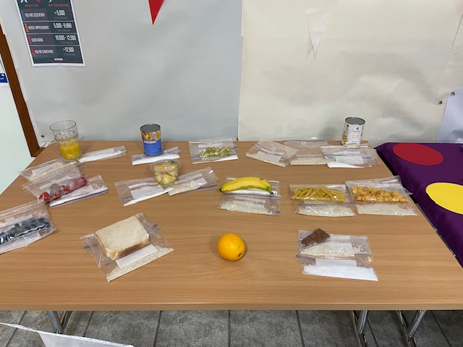

Natalie, our Practice Nurse, brought in various foods to show how much sugar and carbohydrates are in each which was very surprising!

Andrew, the Physical Activity Coordinator from Hinckley and Bosworth Borough Council was there promoting steady steps.

Karen and Georgia from Active Together Leicestershire, Leicester and Rutland, were there chatting to patients about what local activities are on offer and how to ‘Let’s Get Moving’

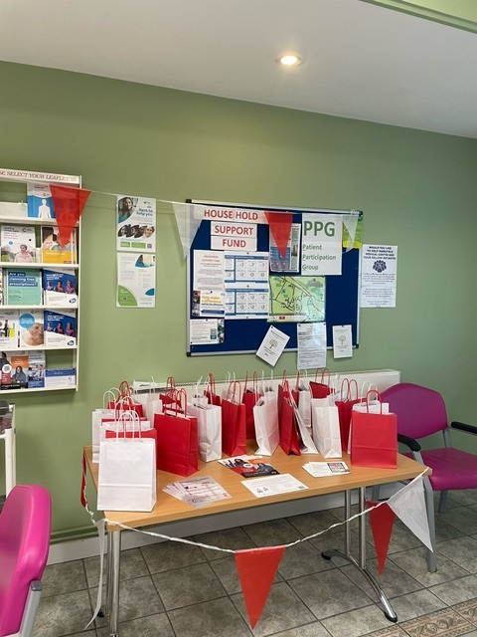Markfield Medical Centre provided packs for patients that attended.

These included: -

* Pedometer
* Food Labels made easy booklet – diabetes UK
* Active together leaflet
* LLR joy information card
* Eat Better book - British Heart Foundation
* Red heart pin badge