Community Groups in Markfield and surrounding area
2024-25

Monday | Tuesday | Wednesday | Thursday | Friday | Saturday | Sunday
Mayflower Friendship Club  2.00-4.00  Markfield congregational church  For more information Tel: 07885 243033 or 07904 222552 or email ronniegrantham@hotmail.co.uk | Coffee morning – Brew about you  Markfield Congregational Church  9.30am -11.30pm | Mayflower Club session  2pm to 4pm.  Markfield congregational church  For more information Tel: 07885 243033 or 07904 222552 or email ronniegrantham@hotmail.co.uk | Music Café  Markfield methodist church  £1.50 session  2nd and 4th Thursday of the month. | Markfield Community centre  Dance Fit: All adults of all abilities welcome, stay active in a fun social environment.  When: Friday 1:20pm-2:10pm  Cost: £3.50 per session | Village Ramblers  Newtown linford-  2nd Saturday of each month | Tea Parties  FREE  The last Sunday of every month between 1 pm - 3 pm.  Transport may be provided  135 Main Street, Stanton Under Bardon, LE67 9TQ
Mayflower CREATIVE ARTS AND CRAFTS SESSIONS 2pm to 4pm.  £2.50 per session  Markfield congregational church | Gardening Club  4th Tuesday of the month  For more information on club email 32couling@gmail.com or by telephone on 01530 242452 Anne and David Couling. | Art Club  10am  Church – Newtown linford | Coffee Mornings Newtown Village Hall  11.15am | Craft Club  10.30am  @ Ulverscroft Activity Centre  £3.00 per session  Every Last Friday of the month
Markfield Community centre  Connect Club: A warm and welcoming social activities group for adults of all ages and backgrounds in a fun and friendly environment. Activities such as arts & crafts, Classic films, Book Club, Guest speakers, themed events, games, smart moves and refreshments.  When: Mondays 1:15pm-2:45pm  Cost: £2 per session | Tai Chi  @ the Newtown Linford Village Hall  4pm | Bodyblast Classes  Newtown Linford Village Hall  6.30pm | Markfield Community centre  Table Tennis: All abilities, ages and genders welcome for table tennis. Meet new people and have fun.  When: Thursday 1:30pm-2:30pm  Cost: £3.50 per session | Stepping Stones for ANXIETY & DEPRESSION  10.00am  @ Ulverscroft Manor £4.00 per session  Every First and Third Friday
Monday activities at Newtown Linford village hall:  1.30pm Dance Fitness for 50+  6.30pm Yoga at Village Hall  8pm Balboa Dance at Village Hall | Markfield Community centre  Senior Circuits: A fun based and motivating circuit session for older adults, specially designed with low impact moves, involving both cardiovascular and resistance exercises. Great for body and mind.  When: Tuesdays 11:30am-12:15pm  Cost: £3 per session. | Markfield Community centre  Spiritual Stretch: focusing on stress relief, medication, strength training and flexibility.  When: Wednesday 10:45am-11:35am  Cost: £3.50 per session | Mindfulness with Emma  Every 3rd and last Thurs of the month at Ulverscroft Grange  11.30am  To relax, reduce stress and anxiety and focus on breathing.  Cost £4.00
Bradgate park Wellbeing walks  Easy access walks 10-11am, every Monday  Moderate walks  10-11.30am, every Monday  Start and meet at Newtown Linford Bradgate car park | Shuttlewood Singers with Caroline Sharpe 1.00pm – 3.00pm Activity Centre.  £4.50 per sesssion | Markfield Community centre  Walking sports: A slower version of various sports with lots of fun. Meet new people and make friends. Suitable for anyone and great for all abilities. Sports can include football, hockey, cricket, tennis, rugby, basketball, rounders, and table tennis.  When: Wednesday 1:30pm-2:30pm  Cost: £3.50 per session | ART - Fun with Art with Steve Bird  1.00pm –  Ulverscroft Activity Centre Every First Thursday of the month  £5.00 per session
Markfield Library Book club every first Monday of the month 2-3pm  Evening book club 6-7pm every 6 weeks | Tai Chi / Chi Kung with Stephanie  10.30am  @Ulverscroft Activity Centre  £5.00 per session  Every Second Tuesday | Thornton tea’s with a twist  2-4pm  Every 2nd and 4th Wednesday  Join for Cuppa, cake and a chat  @ Thornton Community Centre | Book Club  11.30am  Ulverscroft Manor- Every First Thursday of the month  Free
Motivate Monday with Amanda  1.00pm  Ulverscroft Manor Lawn FREE | Yoga Gentle Yoga with Paula  10.30am  @ Ulverscroft Activity Centre  £5.00 per session  Every first, third and last Tuesday |  | Mindfulness with Emma  11.30am @ Ulverscroft Activity Centre  £4.00 per session  Every Third and Last Thursday of the month
Slimming & Fitness  @ The Linford  9.30am |  |  | PILATES Seated Pilates with Liz  Ulverscroft Activity Centre & Zoom  £4.00 per session
Relaxation with Lorna 11.30am
Ulverscroft Activity Centre
£4.00 per session
Chair based seated Yoga with Lorna
10.00am
@ Ulverscroft Activity Centre
£4.00 per session

Markfield Community centre

For more information about any of the sessions at Markfield community centre you can contact Mesports in the community on 01530 242 240, or email markfield@megroup-uk.co.uk.
Website is www.megroup-uk.co.uk.

Ulverscroft support groups
Ulverscroft Grange, Whitwick Road, Ulverscroft, Markfield, Leicestershire LE67 9QB – Also has a variety of specific groups :

Community allotment
Volunteers needed to help with light tasks to maintain our grow with us project. Project aims to nurture community links, increase skills and knowledge and create a positive enjoyable learning environment.

Fibromyalgia Friends – 1.15pm – Ulverscroft Manor Every Third Thursday –January 18 th For more information call - 0116 298 8007 (Monday to Friday 12noon – 4.00pm

Lipoedema support group – 1.00pm – Activity Centre Every Third Thursday – January 18 th Come and have a coffee and chat with Lipoedema friends. For more information contact Kathleen 07860 639693

MS Drop-in Support Group - 1.30pm-3.00pm – Ulverscroft Manor Every Third Monday – January 15th MS support group meeting at the Manor. For more information, please contact 07860 639693.

Pulmonary Fibrosis Support Group - 1.30pm – 3.30pm – Activity Centre Every Second Thursday – January 11 th Have you or someone you care for been diagnosed with pulmonary fibrosis? Would you like to meet and talk to others in the ‘same boat?’ For more information telephone 07588 169494

Young Onset Dementia support group – 1.30pm – Activity Centre Every Last Thursday – January 25th A social group for people under 70 years of age, with Young Onset Dementia, their partners, friends, or Carers to enjoy Today. Support, Chat & Laugh Together. Activities include Kurling, Skittles, Boccia, Quoits. Please call Kathleen 07860 639693 for more information.

Markfield Good Neighbour Scheme
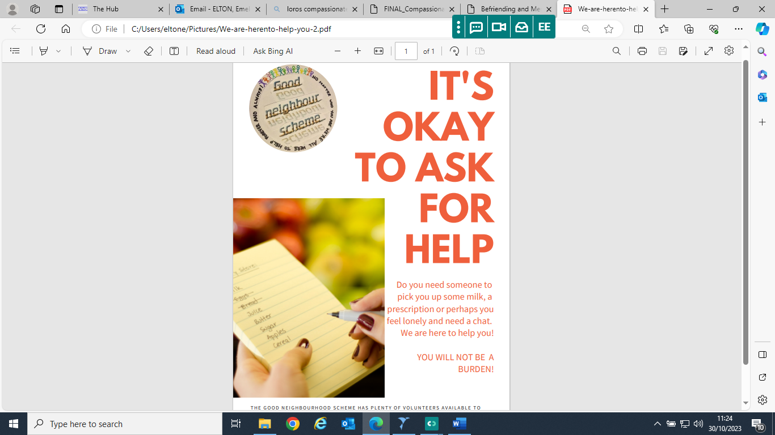
The Scheme number is:
07885 243033

